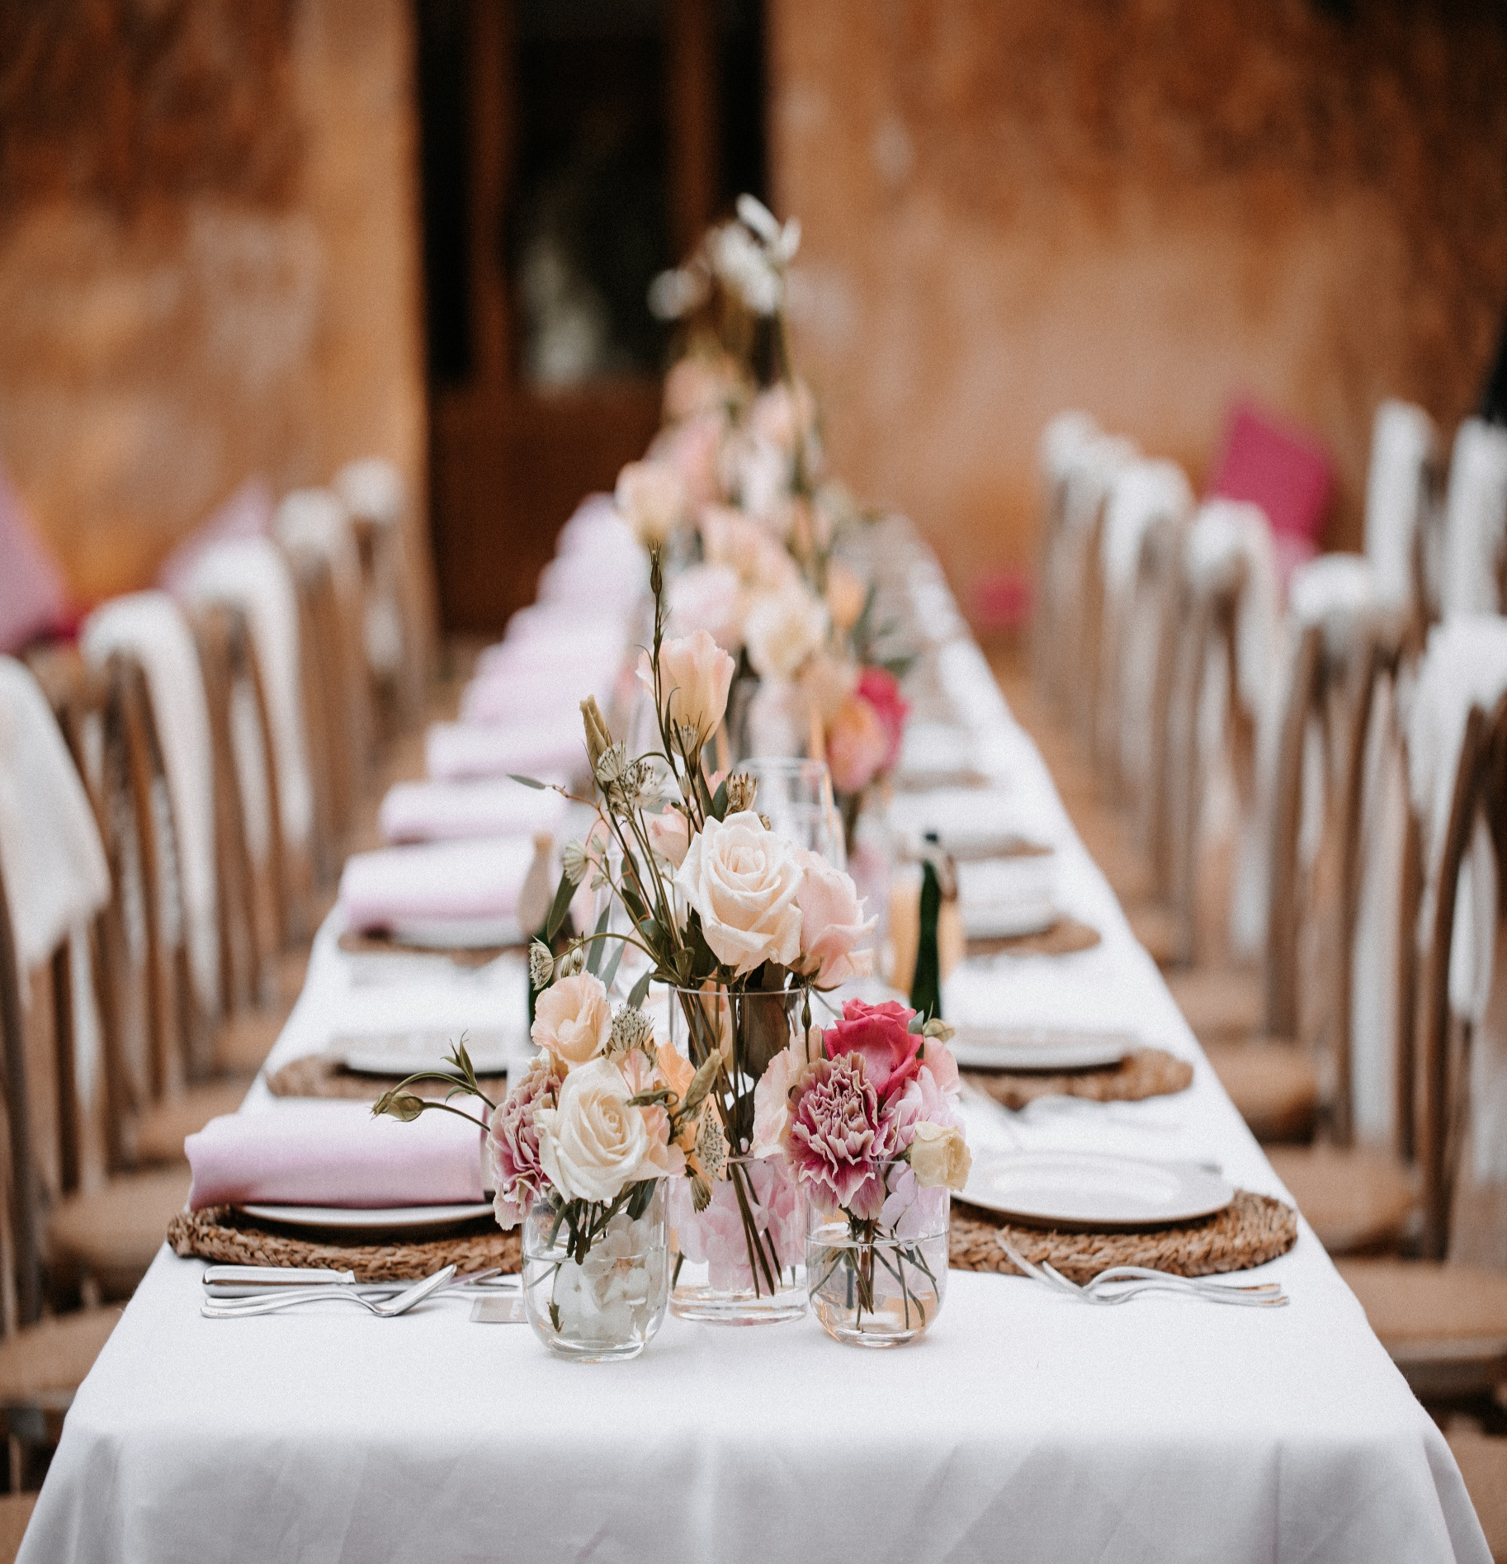


Plated Menus
www.casalinga.ca 778-878-1815 catering@casalinga.ca

Plated Dinners

3-Course Plated Dinner* $77
Min 10ppl
1st course 2nd course 3rd course
Salad Starch, vegetable, 1 protein Dessert

4-Course Plated Dinner* $88

Min 10ppl
1st course 2nd course 3rd course 4th course
Salad Pasta Starch, vegetable, 1 protein Dessert

Family-Style Plated Dinner* $70
Min 50ppl
1st course 2nd course 3rd course
2 Salads 2 ea Starch, vegetable, protein Dessert

*Price based on 60 guests. Add $6pp for under 60 people
Includes plates, cutlery, & staff. Final bill subject to 20% gratuity and 5% GST.




Gluten-Free Vegetarian Vegan
Food Choices:

*Please specify if you need vegetarian/vegan or GF options

Salads

- Casa’s Salad
- Italian garden
- Caesar
- Greek
- Caprese spinach
- Tuscan pasta
- Deluxe mixed greens
- Thai quinoa crunch
- Lemon orzo with capers
- +$3 Deluxe Caprese (layered heirloom tomatoes, fior di latte, basil & balsamic reduction)

Pasta Dishes
Prepared Pastas:

- Chicken fettucine alfredo
- Penne a la vodka
- Spaghetti carbonara
- Shrimp pasta puttanesca

Baked Pastas:

- Spinach & cheese cannelloni
- Meat & cheese lasagna
- Chicken & spinach alfredo lasagna
- Grilled vegetable lasagna
Build Your Own Pasta:
1) Choose pasta 2) Choose sauce 3) Choose protein

Penne, spaghetti, fettucine, rotini, tortellini
Alfredo, Marinara, Rose, Pesto cream, pomodoro, puttanesca
Chicken breast, meatballs, shrimp, vegan meatballs, Italian sausage, bolognese sauce
Starches

- Rosemary nugget potatoes with roasted peppers & onions
- Garlic & parmesan mashed potato
- Italian style potato gratin
- Lemon roasted potato
- Wild mushroom risotto
- Herbed lemon rice pilaf

Vegetables

- Grilled vegetables with balsamic
- Steamed vegetables with garlic butter
- Roasted root vegetables
- Brown buttered squash with cranberries
- Roasted rainbow carrots with tahini & pumpkin seeds

Meat Dishes
Chicken:

- Caprese chicken breast
- Chicken parmesan
- Chicken Cacciatore
- Herb roasted chicken
- Chicken piccata
- Chicken Marsala
- Chicken Florentine

Beef:

- +$2 Roasted baron of beef with jus & horseradish
- +$5 Italian-style pot roast
- +$8 red wine braised beef short rib
- +$10 prime rib*
requires full service or chef/carving station
- +$8 sous-vide beef tenderloin steaks with rosemary butter or

Pork:

- Apricot glazed ham with Dijon
- Pork Milanese
- Roast pork loin with thyme & apple jus
- Boneless pork chop with sundried tomato cream sauce
- Grilled Italian sausage with stewed tomato sauce

Seafood:

- Potato crusted cod with lemon- caper remoulade
- +$3 Jumbo garlic prawns (or Thai curry)
- +$3 Flame grilled salmon with lemon cream sauce

Vegan/Vegetarian:

- Vegan wellington with cranberries, butternut squash & walnuts
- Vegan meatloaf with gravy
- Stuffed portabella mushroom
- Chickpea stuffed sweet potato

